Change in Institutional Policies and its Impact on Employees’ Performance During Covid-19 Pandemic: An Analysis of The Higher Education Sector in Pakistan

**Sobia Jamil**

*Faculty of business administration - Jinnah University for Women, Karachi, Pakistan.*

[*sobiajamil901@gmail.com*](mailto:sobiajamil901@gmail.com)

**Muhammad Irfan Khan**

*Chairperson, Dept. of business administration - Jinnah University for Women Karachi, Pakistan*

[drirfankhan2015@gmail.com](mailto:drirfankhan2015@gmail.com)

**Sherbaz Khan**

*Managing Editor – PBR – IoBM – CBM Karachi, Pakistan*

[analyzeus@gmail.com](mailto:analyzeus@gmail.com)

**Maria Yousuf**

*Student, Dept. of business administration - Jinnah University for Women Karachi, Pakistan*

# Abstract

*This study looked at how change policies affect employee performance in connection to technical developments, organization culture, structure, and culture. A particular research approach was used in the study. The target demographic consisted of 300 employees. Using a simple random selection procedure, a sample size of 250 workers was chosen. Questionnaires schedules were used to obtain primary data. The analysis was carried out using descriptive statistics and was provided in the shape of figures and charts. The research found that physical changes, as well as organizational leadership, had a positive influence on university performance employees. According to the report, technology developments positively affect employee performance since the world is fast shifting to lessen employee workloads and boost efficiency and productivity at work. A great company culture encourages cohesion and motivation, which fosters teamwork and boosts employee performance. The research revealed that structural improvements, leadership, technology, and corporate culture are all important considerations that substantially influence employee performance. Its research advised that university leaders adjust their perspectives on the effect of change management, adopt leadership styles that promote employee incentive to surpass expected outcomes, and use a direct consequence change method to improve employee performance.*

**Keywords:** *Employee performance, institutional policies, higher education*

# Introduction

People, organizations, institutions, and society are constantly faced with many nebulous difficulties and issues in this era of rapidly shifting globalization (Akinbowale, Jinabhai, & Lourens, 2013). They are constantly triggered by these difficulties, which puts them in a precarious position from a survival standpoint. A college degree is useless. At this time, the biggest unknown is the future. There was a constant flow of information in universities about the digital footprints students left during class. The data collected has been used to improve education at many institutions. The ultimate goal of colleges was to foster an atmosphere conducive to critical thought and the dissemination of knowledge (Al Kahtani, 2013). Both formally organized (group work or evaluation projects) and informally organized groups of college students were required to share knowledge (Al-Jaradat, Nagresh, Al-Shegran, & Jadellah, 2013). (Wall & Walsh, 2018) summarized that staff members need to improve their skills to increase their efficiency on the job. If organizations have competent team members, this helps them improve their interpersonal skills (Antwi-Boampong & Bokolo, 2021). The spread of Covid-19 has had a devastating effect on Pakistan's university system.

Employees in universities and colleges experienced severe mental health issues due to the pandemic and thus could benefit from increased access to support services (Kansal & Singh, 2016). To keep their staff members healthy and happy, many colleges and universities now offer services for counseling, webinars, and awareness initiatives for issues related to mental health (Khan, Abbasi, Waseem, Ayaz, & Ijaz, 2016). Initiatives, workers were able to lessen the negative effects of anxiety, burnout, and stress on their health and happiness. Companies often provide training and development opportunities for their employees (Maharani, Troena, & Noermijati, 2013). This information's dissemination has raised the university's knowledge practices profile (McLagan, 2002). Plan thoroughly, especially in first-world countries. In which permissions for utilizing intellectual capital practices have been systematically amassed, Even a prestigious educational institution had to deal with international contracting issues (McLagan, 2002). In this way, we can produce workers capable of exemplary performance. Universities need to emphasize learning and knowledge (Mukhebi, 2019).

Although the personal performance was a significant problem for public universities when it came to successfully comprehending global institutions' goals, public universities have always needed staff, which is good in theory and practice. Because as stated by (Tsai et al., 2018), this was the case. Changing the structures of more traditional institutions was greatly aided by traditional leaders. Everyone on staff knew what they were doing when effectively involving team members in upkeep (Odero & Makori, 2018). Difficulties may evolve into adaptable leaders, protectors of the environment, or catalysts for positive change. Organizational changes must be coordinated, integrated, supported, and implemented across institutions (Osunsan, Florence, Augustine, Abiria, & Innocent, 2019). That is, in many public universities, the work and reputation of every member of the faculty of the institution's staff (managers, staff, faculty, deans, members, and in all fields of coursework) relied on getting a suitable degree of orchestrated set functioning (Pienaar & Bester, 2006). All universities and colleges need to have conversations about sustainability. Sustainability is a broad concept that leaders must use (Straub, 1989).

## Problem Statement

Worker output increased with new elements (institutional framework, technology, and personnel) (Al-Jaradat et al., 2013). Because of universities, there was a constant need for change over a long period to adapt to the circumstances while retaining customers. Those in charge of its development often needed an appreciation for the difficulties inherent in operational change management and a comprehension of the factors that contributed to its persistence. The report highlighted policy implications, saying schools needed to assess curriculum reform to prepare for online education in light of the pandemic threat. Leadership Any shift in a leader's outlook, demeanor, or actions will have far-reaching consequences because it will have been processed due to their inclination and will have either initiated workers' desire to engage or forced them to contribute freely.

## Objective of the study

One of the essential uses for performance determining is the steps institutions take to improve staff efficiency on the results through the systematic application of structure, leadership, culture, and technology.

* Research how different types of organizational change affect workers’ productivity.
* To learn how effective leadership during transitions can affect productivity.
* This study aims to examine the effects of shift technology on employee performance.
* To observe the effects of change culture on productivity.

## Research Questions

Here are some questions to probe further:

* What adjustments must be made to the internal structure of the institution’s policies before the staff will accept them?
* How is the pandemic administration of human resources viewed when recruiting top talent?
* How can we encourage our team to try new things in time for COVID-19?

# Literature Review

Many organizations have revised their approaches to environmental, policy, cultural, and demographic shifts (Tarekegn, 2020). Higher education as an institution, with its unique operations and investigations at the level of the institution, had a significant impact, replacing the previously dominant institutional, university operational, and university activity factors (Teichler, 1999). Persistent COVID-19 chaos had us rethinking many things, and it showed us that businesses and separate management teams need many adjustments to get through this testing period. Understanding how businesses and individuals have adapted to these challenges is the motivation behind this research (Thamrin, 2012). Human resources managers were held to account as part of a remote administration program to facilitate the successful completion and direction of work from home. In response to this need, the Minister of the Republic of Indonesia proposed allowing people to study and work remotely (Wall & Walsh, 2018). Schooling The Covid-19 pandemic has caused significant changes in employment law and policy in Pakistan.

Let us dig deeper into this question and figure out how the policy of the organization shifts affected worker output throughout the pandemic (Wanza & Nkuraru, 2016). One of the most notable institutional policy shifts during the epidemic was the introduction of remote employment and lenient rules (A. A. Khan et al., 2016). Many Pakistani businesses have instituted work-from-home policies to keep running and keep their employees safe (Miao, Jalees, Qabool, & Zaman, 2020). This update helped lessen the spread of viruses among workers and allowed workers to do their jobs from anywhere. Policies like flexible hours and deadline extensions have been implemented to help workers juggle work and personal commitments like child care and household chores (S. I. Zaman, Jalees, Jiang, & Kazmi, 2018). It meant less commuting time, a more pleasant work environment, and increased employee privacy. Better work-life balance results from flexible regulations that give workers more say over when and how long they work (B. Khan, Aqil, Alam Kazmi, & Zaman, 2023).

Employee satisfaction rises alongside morale and output when employers allow for some degree of workplace flexibility, such as telecommuting (I. Zaman, Beevers, Ahmed, Lasserson, & Knight, 2021). Many companies have instituted new safety and health procedures to protect their employees in light of the pandemic. Workplace masks were mandated, and new rules were established for personal space, temperature monitoring, and cleaning surfaces (S. Khan, Khan, Rais, & Aziz, 2023). The implemented health and safety measures gave workers confidence, reducing stress and boosting output. Client retention was boosted (Zafar, Khan, & Khan, 2022). Employees feel invested in and dedicated to their jobs when they believe their bosses care about their well-being and security (Miao et al., 2020). Companies had to spend money on training and developing employees' skills to help them adjust to new technologies and remote work methods in response to the pandemic (Khan, Rasheed, Rashid, Abbas, & Mahboob, 2022). They are resulting in pervasive reforms. Let us examine how these new regulations will impact employees' productivity during the epidemic (Benner, 2019). Due to the closure of educational institutions and the need for social separation, Pakistani higher education institutions have transitioned from in-person instruction to online learning platforms (Breit, Andreassen, & Salomon, 2016). With the transition to online education, revised norms and standards for pedagogy, evaluation, and student participation became necessary. Teachers have had to rapidly acquire new digital skills and instructional strategies as they adapt to online teaching platforms and resources (Brems & McCoy, 2019). Their workload has increased as instructors are required to prepare and present online lectures, develop digital course materials, and provide online assistance to students (Briney, Goben, & Zilinski, 2017). Institutions provided instructors with training and support to help them become more proficient in online teaching strategies, which improved student outcomes in the online classroom. c. Education and professional growth. Universities and colleges have adopted flexible work arrangements, such as remote work options and flexible hours, to ensure the safety of their employees and the consistency of administrative and support services (Budzińska & Majchrzak, 2021). Flexible work arrangements that permitted employees to reconcile personal and professional obligations improved work-life balance and decreased stress levels (Cardinal & Kim, 2017).

Since they spend less time commuting and more time working, remote employees are more productive overall. They gave employees a choice of how and when to work, increasing morale and productivity (Chigudu & Chavunduka, 2021). Several universities and colleges took precautions to guarantee the health and safety of their employees during the pandemic. The plan included mandatory mask use, social isolation restrictions, stringent hygiene practices, and fewer opportunities for physical contact (Decramer, Smolders, Vanderstraeten, & Christiaens, 2012). Implementing health and safety measures increased workers' sentiments of safety and decreased their health concerns, positively impacting workers' satisfaction and output. Employees with a sense of employment security can focus more attentively on their work, enhancing performance and productivity (Dougherty et al., 2014). Colleges and universities now recognize the need to better equip their faculty with the technological and pedagogical skills required to instruct in an online or blended environment (Findler, Schönherr, Lozano, & Stacherl, 2018). As a result, businesses began providing professional training, such as seminars and webinars, to bring employees up to speed (Fornell & Larcker, 1981). Improved student engagement and learning outcomes result from faculty members' increased use of newly learned teaching strategies and digital technologies from professional development programs (Grant & Cosentino, 2019). They have improved online course delivery due to greater familiarity with online platforms and technologies gained through training and development opportunities (Hurduzeu, 2015). Instructors, employees, and administrators needed to collaborate and communicate effectively during the epidemic. Institutions' virtual communication tools and platforms facilitated regular online communication, coordination, and decision-making (Johnson, Roberto, & Rauhaus, 2021). Due to improved coordination between teams made possible by virtual communication technologies, cooperation and productivity are enhanced. Regular contact and virtual meetings bolstered staff members' motivation and output and reduced their likelihood of experiencing isolation and alienation (Jumanne & Keong, 2018).

As a result, many Pakistani companies now offer their staff members access to online training modules and in-person seminars. Employees benefited from training in areas like working from home, interaction, and using electronic devices to handle better the dynamic and ever-evolving nature of the modern workplace. Job satisfaction rises among workers who are given chances to learn new things and grow in their careers. Reliable means of communication and aid were critical during the epidemic (Miao et al., 2022). Many organizations in Pakistan now use video calling and messaging apps to keep in touch with their staff and offer advice and assistance virtually.

* Effective teamwork: Online interaction technologies allow Workers to collaborate, share information, and solve issues more quickly and efficiently.
* Consistent interaction and assistance networks reduced employees' feelings of loneliness, increasing their motivation and engagement.

Employees' mental health suffered due to the epidemic, which brought about additional stress, uncertainty, and isolation. When businesses realized they needed to invest in their employees' mental well-being, they often began offering counseling services, seminars, and employee assistance programs (S. Khan, Rashid, Rasheed, & Amirah, 2023). The efforts to improve workers' mental health helped them handle the stresses of the pandemic better. When cared for psychologically, workers can work harder and produce better results (Qadeer, Javed, Manzoor, Wu, & Zaman, 2021). Pakistan's remote employment and flexible policy, safety and health measures, education and training, interaction and encouragement systems, and psychological promotion underwent significant revisions in response to the Covid-19 pandemic (Jiang, Xiao, Jalees, Naqvi, & Zaman, 2018). Increases in output, work-life Hara, sense of purpose happiness, a sense of purpose, job satisfaction, teamwork efficiency, and reductions in feelings of isolation can be attributed to the new policies (S. Khan, Zaman, & Rais, 2022).

## Theoretical Foundation

The increased stress, unpredictability, and isolation felt by workers during the epidemic negatively impacted their mental health. Therapy services, seminars, and programs for staff assistance became commonplace as companies recognized the importance of tending to their workers' emotional health. The stress of the pandemic was lessened thanks to efforts to enhance worse mental health. When employees' emotional needs are met, they are more motivated to put in extra effort and produce higher-quality work. The Covid-19 pandemic prompted significant changes to Pakistan's working-from-home and adaptable policy, safety, and health policies, training and instruction, communication and support systems, and psychological promotion. The new policies have increased productivity, improved work-life balance, greater employee happiness and purpose, greater job satisfaction, more effective teamwork, and fewer feelings of isolation.

## Organizational Structure on Employee Performance

A company's organizational structure helps it establish its identity and spread its values. A solid organizational structure is crucial for a company going through a transition, and any flaws can cause the information to leak out of the company. According to (McLagan, 2002), the organizational framework had three distinct shifts. They could be taken elsewhere, altered, and used differently (Agha, Rashid, Rasheed, Khan, & Khan, 2021). Minor adjustments, like training, a new incentive structure, or software redirection, were all needed to implement the transferable change (Nafees et al., 2022). The critical role of rational team diversity was identified, and the when and how of information conveying's advantages to group innovation were investigated. The effect of the organizational framework on staff efficiency is investigated.

**H1:** There is a significant impact of organizational structure on Employee Performance.

## Technological Changes on Employee Performance

Staff was essentially social distances; they were categorized as such because they had the propensity to connect with others and engage in various social interactions (Jamil, Shah, Khan, & Imran, 2023). Individuals in various contexts have tested the concept of social distance, each with unique advantages and disadvantages. The term "theory test" was also commonly used to describe this exercise. However, the expected lifespan of various computer systems was suddenly rendered obsolete by the exponential growth of technology. Many times the outcomes of this inventiveness could have been more pleasant. This research shows that the practical effect of technological advancements on employee performance fails in half of the technological transformation projects studied.

**H2:** There is a significant impact of Technological Change on Employee Performance.

## Organizational Leadership on Employee Performance

The rapid changes during COVID-19 presented significant challenges to the leaders of this era. The onus was on leaders to increase their organizations' resilience amid adversity by fostering a culture of trust, engagement, and shared authority (Qadeer et al., 2021). For example, leaders chose virtual offices to preserve personal space. According to (Hurduzeu, 2015), adequate supervision relies on several factors: employee satisfaction, managerial skill, inspiration, recognition, and compensation. When resources allowed, he compelled businesses to report increased employee motivation, positively impacting output and revenue. This study found that effective organizational leadership positively impacted worker productivity.

**H3:** There is a significant impact of Organizational leadership on Employee Performance.

## Organizational Culture on Employee Performance

Values, trusts, sets, stated communication relations, and supported behaviors all contribute to what is known as "culture." Working remotely, primarily online, has positively affected productivity, flexibility, job satisfaction, and balance between work and personal life (Grant & Cosentino, 2019). The foundation of the institutional framework is the maintenance of a training culture. This study found that a company's culture can significantly impact employee productivity.

**H4:** There is a significant impact of Organizational Culture on Employee Performance.

The Covid-19 epidemic has had a devastating impact on the academic community in Pakistan's universities. The shift from traditional classroom learning to more convenient online resources was one of the most apparent results of the pandemic. Universities need to implement new technologies and online platforms for distance learning immediately. Instructors must be familiar with emerging technologies, pedagogical resources, and potential roadblocks to implementing online courses effectively. Despite the setbacks, this change has allowed for more experimentation and inquiry in the learning environment.

Furthermore, since the outbreak began, organizations have taken numerous measures to guarantee the well-being of their employees. Respirator use was mandated, as was social isolation, hand washing, and minimal contact with others. Efforts to stop the spread of the virus impacted productivity in the office. The workers needed time to adapt to the regulations and processes that the safety evaluations instituted. Furthermore, remote employment and flexible schedules became commonplace, enabling workers to complete their tasks from the comfort of their own homes. Employees disclosed greater satisfaction with work and overall health due to increased opportunities to reconcile personal and professional lives.

As a result of the pandemic, universities understood they needed to make more significant investments in the professional development of their faculty and staff. The success of online courses relies on universities investing in their faculty members' digital literacy and pedagogical knowledge. In response, many schools now provide faculty members with online access to pedagogical tools like webinars, seminars, and courses for continuing education. Increased comfort with technology, better teaching methods, and more involved students result from the time and money spent on training. Teachers were given the freedom to try out novel approaches to education and the tools to make their lessons more interactive and exciting for students. Effective coordination and communication were crucial throughout the pandemic. Educators, staff, and university administration all used various forms of online communication to stay in the loop and work together effectively. Members of dispersed teams were brought closer together through video conferences, electronic mail, and other remote communication and teamwork forms. It is possible to overstate the value of open lines of communication in terms of informing staff, creating a sense of community, and encouraging teamwork. The challenges were the need for effective communication channels and connectivity problems.

## Theoretical Framework

This study investigated the impact of change policies (organizational, top-level, cultural, and technological) on worker output.

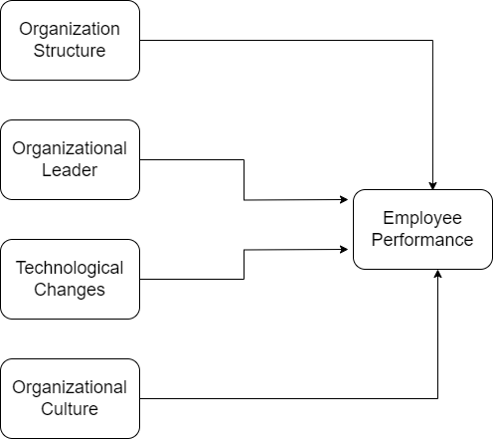

Researchers Sr. Lucy Wanza and Janet Kagwiria Nkuraru (2016) looked into the impact of modified laws on employee performance and how they impacted performance

# Research Methodology

A method of research was a predetermined plan for investigating a problem. The research methodology includes methodical preparation, in-depth analysis, selecting a suitable study design, appropriate sampling techniques, reliable data sources, careful tabulation, and using appropriate instruments and techniques.

## Proposed Research Method

The research employed a descriptive and explanatory design. Finding answers to questions about the demographic characteristics of the participants indicated that a descriptive design was appropriate. This investigation combined descriptive and causal methods to examine how people believe institutional change policy affects worker productivity. It was common practice to use explanatory research designs to explain the relationship between a given variable and a set of observed results (Tarekegn, 2020).

Calculating EP: OS+OL+TC+OC

## Proposed Sample Size

Academic faculty were considered among the most crucial parts of universities due to their critical role in teaching. Data was collected from a wide range of Karachi, Pakistan, university faculty, including administrators, supervisors, and teachers. Three hundred people made up the total population. Sampling-based data collection

## Proposed Data Collection Techniques

The information was gathered from private and public institutions of higher learning in Karachi, Pakistan. Questionnaires were the primary method of data collection. In order to answer research questions and select between possible causal relationships, we applied the theoretical framework's prescribed methods of inquiry to the data, including a descriptive analysis to provide context and an exploration of correlations between variables.

## Ethical Concerns

The study assured participants that their responses to the questionnaire would be kept private and used for pedagogical purposes. Participants could politely decline to answer questions they found offensive without fear of repercussion. Participants were assured that their responses would remain anonymous. Participants were typically assured of their anonymity and privacy out of respect for ethical concerns and to protect their information.

# Discussion and Results Analysis

## Demographic Characteristics

Demographic investigation revealed the following data provided in Table 1. Regarding gender, the data shows that 56.4 percent of respondents were male and 4.6 percent were female. Concerning age categories, 26.3 percent of respondents were age range: 21-29 years, 36.5 percent were 30-39 years, 32.1 percent were 40-49 years, and 5.1 percent were 50 or more.

**Table 1**: *Respondent profile*

*-Insert Table 1 in Appendix-*

## Result

The constructs' reliability, validity, discriminate validity, and convergent validity were examined in this study to determine their overall competency.

**Table2**: *Private Universities*

*-insert Table 2 in Appendix*-

The results of a framework for measurement are shown in Table 2; Cronbach's alpha for all variables is greater than 0.7, so the model meets the required standard. According to research, Composite dependability needs to be greater than 0.7, as stated by (Straub, 1989). The current research used AVE (average variance extracted) presented by (Fornell & Larcker, 1981) to assess convergent validity; the table shows that each variable's AVE value of less than 0.5 did not permit convergent validity of the measurement model.

**Table 3**: *Discriminant validity (Fornell-Larcker Criterion)*

*-insert Table 3 in Appendix*-

Using cross-loadings and AVE (average variance extracted), Table 3 demonstrates discriminating validity. Values of AVE should exceed construct correlation, as stated by (Fornell & Larcker, 1981). According to the results of the FLC, the diagonal values are appropriate (Fornell & Larcker, 1981).

## Structure Model

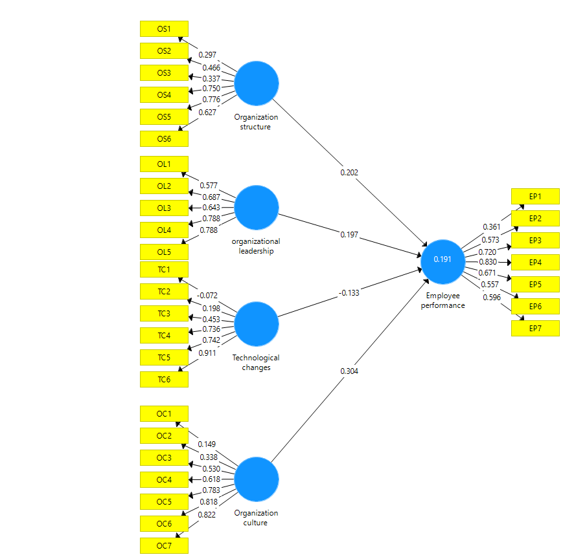The structure model was analyzed using the standardized procedure. Moreover, every avenue was analogous to the theory being examined. The outcomes of the route analysis are shown in Table 4.

-Insert Table 4 in Appendix-

- Insert Table 5 in Appendix-

- Insert Table 6 in Appendix

Table 6 demonstrates discriminating validity using cross-loadings and AVE (average variance extracted). According to (Fornell & Larcker, 1981), the AVE value should be larger than the construct correlation. FLC findings showed that the diagonal values meted the requirements of (Fornell & Larcker, 1981).

## Structure Model

The structure model was analyzed using the standardized procedure. Moreover, every avenue was analogous to the theory being examined. The outcomes of the route analysis are shown in Table 4.

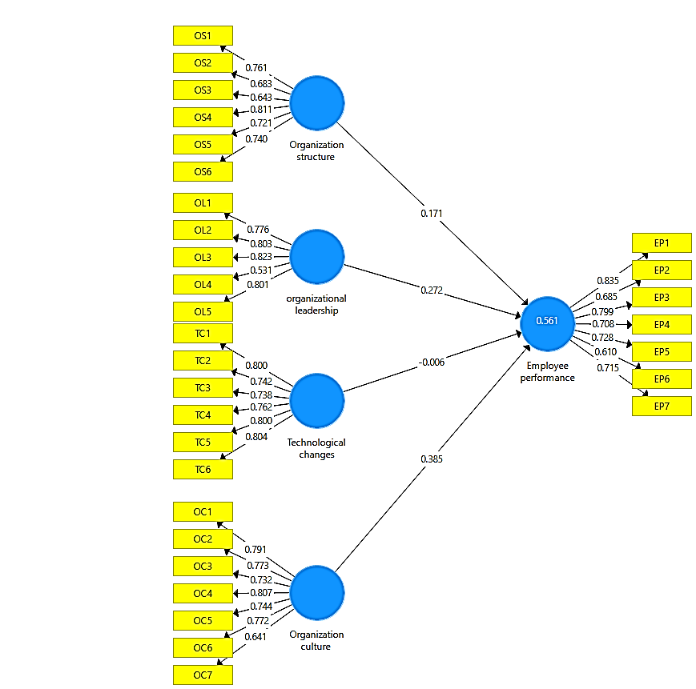

- Insert Table 7 in Appendix

## Comparison of both universities

The information is compiled from two Karachi universities, and the findings show that they differ significantly in key respects. The organizational structure of private universities had a Cronbach alpha of 0.784, leadership of 0.752, the impact of technology on the workplace at 0.816, the importance of culture at 0.774, and the efficiency of employees at 0.755. Government universities scored high marks in organizational structure (0.824), leadership (0.805), and adaptability to new technologies (0.867), culture (0.872), and employee performance (0.851). OS private universities had a lower Cronbach alpha than govt universities. Likewise, OL ate universities had a lower Cronbach alpha than govt universities. Likewise, TC private universities had a lower Cronbach alpha than govt universities, OC private universities had a lower Cronbach alpha than govt universities, and EP private universities had a lower Cronbach alpha than govt universities. The AVE for organizational structure at private universities was 0.329; for leadership, it was 0.492; for technological change, it was 0.362; for culture, it was 0.394; and for employee performance, it was 0.397. Organizational structure at public universities scored 0.531, leadership at 0.570, technological innovation at 0.560, culture at 0.567, and employee performance at 0.532. There was a negative relationship between the AVE of private and public universities in all five regions: the AVE of private universities in OS was lower than that of public universities in OL, TC, OC, and EP. Organizational structure at private universities had an FLC value of 0.574, leadership at 0.701, technological innovation at 0.602, culture at 0.628, and employee performance at 0.630. Government universities scored 0.72 on organizational structure, 0.75 on leadership, 0.77 on technological change, 0.75 on culture, and 0.72 on employee performance. Private universities in OS had a lower FLC value than public universities in that state, as did OL, TC, OC, and EP. The path analysis of private universities found that OC>EP was acceptable (p=0.005), while OS>EP was not (p=0.316), TC>EP was not (p=0.381), and OL>EP was not (p=0.075). EP had an R-squared value of 0.166. In a path analysis of public universities, we found that the p-value for OC>EP was 0.001; for OS>EP, it was 0.154; for TC>EP, it was 0.962; and for OL>EP, it was 0.002. EP had an R2 of 0.544.

Institutional policies for implementing organizational change and the effectiveness of their staff were the primary focus of this research. This would help upper management pinpoint specific aspects of change policies that significantly affect worker output. The presented data can strengthen the case for policymaking and set up efficient organizational transformation processes. Because it contributes to academic research on changes in organizational policies and worker efficiency in public and private institutions, the study's findings will particularly interest employees and other staff members.

# Conclusion and Recommendations

This research aimed to examine the impact of alterations in institutional policies on the productivity of public and private higher education institutions in Karachi. The study's primary finding was that implementing new institutional norms improved performance among higher education staff in Karachi. The implementation of policy modifications can result in significant impacts on the operational efficiency of businesses. This study aimed to assess the impact of structural modifications in academic organizations in Pakistan on the efficacy of their human resource departments. A critical analysis was conducted on the impact of policy modifications within the institution on its leadership, infrastructure, and technical culture. The findings of our study validate the assertion made by Mukhebi (2019) regarding the pivotal role of technology in propelling the growth of productivity.

The study revealed that the leadership techniques employed by organizations in Karachi significantly influenced their employees' productivity. Jumanne and Keong's (2018) study suggests that inadequate leadership threatens employment as it diminishes employees' dedication to objectives prioritizing quality and hinders efficient communication. The study underscores the necessity of enacting effective policies to enhance institutional leadership, which can elevate employee productivity. The investigation also assessed the impact of technological advancements on the workforce of Pakistan's tertiary education industry. The adoption of state-of-the-art tools by technologically advanced financial institutions in Karachi, which have successfully dealt with cybercrime and financial fraud, indicates a favorable association between such innovations and productivity. The modifications observed prove an inseparable connection between scholarly investigation and technological advancement (Wanza & Nkuraru, 2016).

The study's primary objective was to assess the potential financial benefits that policy modifications could yield for universities located in Karachi. The study concluded that policies aimed at promoting enhancements to infrastructure significantly affected individual workers' productivity. The study conducted by Osunsan et al. (2019) revealed a positive correlation between improved staff performance and the implementation of efficient structural modifications within higher education institutions.

An additional significant area of investigation pertained to the influence of the organizational culture within educational establishments in Karachi on the efficacy of their personnel. It has been inferred that alterations in an organization's culture can significantly influence productivity, particularly within the realm of education. Organizational cultural modifications may elicit resistance and conflict if employees perceive them as threatening their established way of life. As per the findings of Wanza and Nkuraru's study conducted in 2016, it can be inferred that a strategically planned transformation in organizational culture can lead to increased work efficiency. The COVID-19 pandemic has underscored the importance of robust mental health services for higher education institutions. A survey was conducted among university employees to investigate the impact of enhanced availability of professional counseling, webinars, and awareness campaigns on their stress levels and morale. The findings revealed a positive correlation between these interventions and the outcomes above. Consequently, implementing a comprehensive mental health care approach is imperative in addressing challenges such as pandemics and their impact on the psychological welfare of the personnel within the academic institution.

In summary, this study illuminates the extensive impact of the COVID-19 pandemic on the higher education system in Pakistan. The swift adoption of online education pieces of evidence, the integration of health and safety regulations, and the implementation of flexible work schedules. The prioritization of professional growth and an increased acknowledgment of the importance of communication, collaboration, and behavioral support structures. Notwithstanding the obstacles, these evolutionary mechanisms have engendered novel pedagogical and evaluative modalities that have fostered a safer and more agreeable work environment.

## Implications

Implications are as follows:

* The current study focuses on employee performance policy by evaluating the proposed framework, which demonstrates that changes in institutional policy are crucial in affecting employee performance.
* The proposed framework could be applied in other scenarios to yield substantial outcomes by studying and evaluating the outputs from other circumstances with the results from higher educational situations to analyze the likely similar and altering features of employees' performance.
* It would be helpful to see how other companies cope with success by concentrating on comparable or varied change policies about organizational performance. It will aid in approving employees' performance regarding important reforms in deciding employee performance.

## Recommendations

Following are the recommendations.

* Employee performance has been impacted by technology because that clarifies and makes labor highly effective.
* A positive corporate culture will aid in developing positive connections, values, conventions, attitudes, and perspectives. Culture influences how people see their employment.
* The thought, attitude, and conduct of a leader, as well as the transformation they build as an outcome of their direction, must motivate people to engage, to have to engage, instead of forcing them to use it.

# References

Alwi, S. K. K., Rauf, M. B., & Haider, K. (2015). Teachers’ job satisfaction and the role of principles for effective educational system in secondary schools of Karachi, Pakistan. *Research Journal of Educational Sciences*

Agha, A. A., Rashid, A., Rasheed, R., Khan, S., & Khan, U. (2021). Antecedents of Customer Loyalty at telecomm Sector. *Turkish Online Journal of Qualitative Inquiry, 12*(9).

Agha, A. F., Khan Alwi, S. K., & Shaiq, M. (2020). Teachers’perception Of The Effectiveness Of Teachers Appraisal Systems In Private Schools Of Pakistan. *New Horizons (1992-4399)*, *14*(1)

Akinbowale, M. A., Jinabhai, D. C., & Lourens, M. E. (2013). The impact of performance appraisal policy on employee performance–A case study of Guaranty Trust Bank in Nigeria. *Mediterranean Journal of Social Sciences, 4*(14), 677.

Al-Jaradat, O., Nagresh, M., Al-Shegran, A., & Jadellah, N. (2013). Impact of change management on the performance of employees in university libraries in Jordan. *European Journal of Business and Management, 5*(2), 169-178.

Al Kahtani, A. (2013). Employee emotional intelligence and employee performance in the higher education institutions in Saudi Arabia: A Proposed theoretical framework. *International Journal of Business and Social Science, 4*(9).

Antwi-Boampong, A., & Bokolo, A. J. (2021). Towards an institutional blended learning adoption model for higher education institutions. *Technology, Knowledge and Learning*, 1-20.

Benner, M. (2019). Smart specialization and institutional context: The role of institutional discovery, change and leapfrogging. *European Planning Studies, 27*(9), 1791-1810.

Breit, E., Andreassen, T. A., & Salomon, R. H. (2016). Modification of public policies by street-level organisations: an institutional work perspective. *Journal of Social Policy, 45*(4), 709-728.

Brems, J. H., & McCoy, M. S. (2019). A content analysis of patient advocacy organization policies addressing institutional conflicts of interest. *AJOB Empirical Bioethics, 10*(4), 215-221.

Briney, K., Goben, A., & Zilinski, L. (2017). Institutional, funder, and journal data policies.

Budzińska, K., & Majchrzak, O. (2021). *Positive psychology in second and foreign language education*: Springer.

Cardinal, B. J., & Kim, M. (2017). Why do university students enroll in physical activity education courses? Differential affects of required versus elective institutional policies. *International Journal of Sports and Physical Education, 3*(3).

Chigudu, A., & Chavunduka, C. (2021). *The tale of two capital cities: the effects of urbanisation and spatial planning heritage in Zimbabwe and Zambia.* Paper presented at the Urban Forum.

Decramer, A., Smolders, C., Vanderstraeten, A., & Christiaens, J. (2012). The impact of institutional pressures on employee performance management systems in higher education in the low countries. *British Journal of Management, 23*, S88-S103.

Dougherty, K. J., Jones, S. M., Lahr, H., Natow, R. S., Pheatt, L., & Reddy, V. (2014). Performance funding for higher education: Forms, origins, impacts, and futures. *The ANNALS of the American Academy of Political and Social Science, 655*(1), 163-184.

Findler, F., Schönherr, N., Lozano, R., & Stacherl, B. (2018). Assessing the impacts of higher education institutions on sustainable development—an analysis of tools and indicators. *Sustainability, 11*(1), 59.

Fornell, C., & Larcker, D. F. (1981). Structural equation models with unobservable variables and measurement error: Algebra and statistics. In: Sage Publications Sage CA: Los Angeles, CA.

Grant, P. J., & Cosentino, F. (2019). The 2019 ESC Guidelines on diabetes, pre-diabetes, and cardiovascular diseases developed in collaboration with the EASD: New features and the ‘Ten Commandments’ of the 2019 Guidelines are discussed by Professor Peter J. Grant and Professor Francesco Cosentino, the Task Force chairmen. In: Oxford University Press.

Hurduzeu, R.-E. (2015). The impact of leadership on organizational performance. *SEA–Practical Application of Science, 3*(07), 289-293.

Jamil, S., Shah, F., Khan, S., & Imran, I. (2023). The The influence of potential outcome on entrepreneurs' decisions to participate in Crowdfunding in Pakistan (Karachi). *International Journal of Social Science & Entrepreneurship, 3*(1), 1-24.

Jiang, Y., Xiao, L., Jalees, T., Naqvi, M. H., & Zaman, S. I. (2018). Moral and ethical antecedents of attitude toward counterfeit luxury products: Evidence from Pakistan. *Emerging Markets Finance and Trade, 54*(15), 3519-3538.

Johnson, A. F., Roberto, K. J., & Rauhaus, B. M. (2021). Policies, politics and pandemics: course delivery method for US higher educational institutions amid COVID-19. *Transforming Government: People, Process and Policy, 15*(2), 291-303.

Jumanne, B. B., & Keong, C. C. (2018). Foreign direct investment and natural resources in sub-Saharan Africa: the role of institutions towards the Africa we want “2063 Vision”. *African Journal of Economic Review, 6*(1), 14-32.

Kansal, K., & Singh, A. (2016). Impact Of Organization Change On Employees Performance In Maruti Suzuki. *International Journal Of Research in IT and Managem ent, 6*(11).

Khan, A. A., Abbasi, S., Waseem, R. M., Ayaz, M., & Ijaz, M. (2016). Impact of training and development of employees on employee performance through job satisfaction: A study of telecom sector of Pakistan. *Business Management and Strategy, 7*(1), 29-46.

Khan, B., Aqil, M., Alam Kazmi, S. H., & Zaman, S. I. (2023). Day‐of‐the‐week effect and market liquidity: A comparative study from emerging stock markets of Asia. *International Journal of Finance & Economics, 28*(1), 544-561.

Khan, S., Khan, M. I., Rais, M., & Aziz, T. (2023). Organizational Productivity: A Critical Analysis of the Impact of Employee Motivation. *Reviews of Management Sciences, 5*(1), 13-37.

Khan, S., Rasheed, R., Rashid, A., Abbas, Q., & Mahboob, F. (2022). The effect of demographic characteristics on job performance: An empirical study from Pakistan. *The Journal of Asian Finance, Economics and Business, 9*(2), 283-294.

Khan, S., Rashid, A., Rasheed, R., & Amirah, N. A. (2023). Designing a knowledge-based system (KBS) to study consumer purchase intention: the impact of digital influencers in Pakistan. *Kybernetes, 52*(5), 1720-1744.

Khan, S., Zaman, S. I., & Rais, M. (2022). Measuring Student Satisfaction through Overall Quality at Business Schools: A Structural Equation Modeling: Student Satisfaction and Quality of Education. *South Asian Journal of Social Review (ISSN: 2958-2490), 1*(2), 34-55.

Maharani, V., Troena, E. A., & Noermijati, N. (2013). Organizational citizenship behavior role in mediating the effect of transformational leadership, job satisfaction on employee performance: Studies in PT bank Syariah Mandiri Malang east Java. *International Journal of Business and Management, 8*(17), 1-12.

McLagan, P. A. (2002). Success With Change. *T+ D, 56*(12), 44-53.

Miao, M., Jalees, T., Qabool, S., & Zaman, S. I. (2020). The effects of personality, culture and store stimuli on impulsive buying behavior: Evidence from emerging market of Pakistan. *Asia Pacific Journal of Marketing and Logistics, 32*(1), 188-204.

Miao, M., Jalees, T., Zaman, S. I., Khan, S., Hanif, N.-u.-A., & Javed, M. K. (2022). The influence of e-customer satisfaction, e-trust and perceived value on consumer's repurchase intention in B2C e-commerce segment. *Asia Pacific Journal of Marketing and Logistics, 34*(10), 2184-2206.

Mukhebi, H. N. (2019). *Change management and employee performance in commercial banks Trans Nzoia county, Kenya.* KIBU,

Nafees, A., Khan, S., Javed, M. F., Alrowais, R., Mohamed, A. M., Mohamed, A., & Vatin, N. I. (2022). Forecasting the mechanical properties of plastic concrete employing experimental data using machine learning algorithms: DT, MLPNN, SVM, and RF. *Polymers, 14*(8), 1583.

Odero, J. A., & Makori, M. E. (2018). Employee involvement and employee performance: The case of part time lecturers in public universities in Kenya. *International Journal of Management and Commerce Innovations, 5*(2), 1169-1178.

Osunsan, O. K., Florence, I., Augustine, W., Abiria, P., & Innocent, B. (2019). Effect of Organizational Change on Employee Performance among selected Commercial Banks in Bujumbura, Burundi. *East African Scholars Journal of Economics, Business and Management, 2*(4), 225-234.

Pienaar, C., & Bester, C. (2006). Typical career dilemmas of academic staff during the early phase within a changing South African higher education institution. *South African journal of education, 26*(4), 581-594.

Qadeer, T., Javed, M. K., Manzoor, A., Wu, M., & Zaman, S. I. (2021). The experience of international students and institutional recommendations: A comparison between the students from the developing and developed regions. *Frontiers in Psychology, 12*, 667230.

Sehar, S., & Alwi, S. K. K. (2019). Impact of head teacher’s leadership style on teacher’s job satisfaction and work motivation. *Journal of Business Strategies*, *13*(1), 1-18

Straub, D. W. (1989). Validating instruments in MIS research. *MIS quarterly*, 147-169.

Tarekegn, M. (2020). *Effect Of Organizational Change On Employee Performance In Case Of Dashen Bank.* St. Mary’s University,

Teichler, U. (1999). Higher education policy and the world of work: changing conditions and challenges. *Higher Education Policy, 12*(4), 285-312.

Thamrin, H. (2012). The influence of transformational leadership and organizational commitment on job satisfaction and employee performance. International Journal of Innovation, Management and Technology, 3(5), 566-572.

Tsai, Y. S., Moreno-Marcos, P. M., Tammets, K., Kollom, K., & Gašević, D. (2018, March). SHEILA policy framework: informing institutional strategies and policy processes of learning analytics. In Proceedings of the 8th international conference on learning analytics and knowledge (pp. 320-329).

Wall, B., & Walsh, P. (2018). Cryptographically Enforced Orthogonal Access Control at Scale. Paper presented at the Proceedings of the 6th International Workshop on Security in Cloud Computing.

Wanza, L., & Nkuraru, J. K. (2016). Influence of change management on employee performance: A case of university of Eldoret, Kenya. *International Journal of Business and Social Science, 7*(4), 190-199.

Zafar, D., Khan, S., & Khan, M. I. (2022). The Factors influencing entrepreneurship capabilities in Pakistan. *International Journal of Social Science & Entrepreneurship, 2*(2), 47-71.

Zaman, I., Beevers, Z. C., Ahmed, R., Lasserson, D., & Knight, T. (2021). NEWS2 to assess suspected COVID-19 in the community: a service evaluation of a primary care assessment centre. *Family Practice, 38*(Supplement_1), i3-i8.

Zaman, S. I., Jalees, T., Jiang, Y., & Kazmi, S. H. A. (2018). Testing and incorporating additional determinants of ethics in counterfeiting luxury research according to the theory of planned behavior. *psihologija, 51*(2), 163-196.

# Appendices

**Table 1:**

*Respondent profile*

|  |  |  |
| --- | --- | --- |
| **Demographic items** | **Frequency** | **Percentile** |
| **Gender** |  |  |
| Male | 141 | 56.4% |
| Female | 109 | 43.6% |
| **Age** |  |  |
| 18-20 | - | - |
| 21-29 | 36 | 26.3% |
| 30-39 | 50 | 36.5% |
| 40-49 | 44 | 32.1% |
| 50 or above | 7 | 5.1% |

**Table 2:**

*Measurement Model Assessment*

|  |  |  |  |  |
| --- | --- | --- | --- | --- |
| **Variables** | **Items** | **Outer Loadings** | **Cronbach's alpha** | **Average variance extracted** |
| Organization structure | OS1 | 0.297 | 0.784 | 0.329 |
|  | OS2 | 0.466 |  |  |
|  | OS3 | 0.337 |  |  |
|  | OS4 | 0.750 |  |  |
|  | OS5 | 0.776 |  |  |
|  | OS6 | 0.627 |  |  |
| Organizational leadership | OL1 | 0.577 | 0.752 | 0.492 |
|  | OL2 | 0.687 |  |  |
|  | OL3 | 0.643 |  |  |
|  | OL4 | 0.788 |  |  |
|  | OL5 | 0.788 |  |  |
| Technological changes | TC1 | -0.072 | 0.816 | 0.362 |
|  | TC2 | 0.198 |  |  |
|  | TC3 | 0.453 |  |  |
|  | TC4 | 0.736 |  |  |
|  | TC5 | 0.742 |  |  |
|  | TC6 | 0.911 |  |  |
| Organization culture | OC1 | 0.149 | 0.774 | 0.394 |
|  | OC2 | 0.338 |  |  |
|  | OC3 | 0.530 |  |  |
|  | OC4 | 0.618 |  |  |
|  | OC5 | 0.783 |  |  |
|  | OC6 | 0.818 |  |  |
|  | OC7 | 0.822 |  |  |
| Employee performance | EP1 | 0.361 | 0.755 | 0.397 |
|  | EP2 | 0.573 |  |  |
|  | EP3 | 0.720 |  |  |
|  | EP4 | 0.830 |  |  |
|  | EP5 | 0.671 |  |  |
|  | EP6 | 0.557 |  |  |
|  | EP7 | 0.596 |  |  |

**Table 3**

|  |  |  |  |  |  |
| --- | --- | --- | --- | --- | --- |
| **Variables** | **EP** | **OC** | **OS** | **TC** | **OL** |
| Employee performance | **0.630** |  |  |  |  |
| Organization culture | 0.343 | **0.628** |  |  |  |
| Organization structure | 0.253 | 0.201 | **0.574** |  |  |
| Technological changes | 0.090 | 0.204 | 0.457 | **0.602** |  |
| Organizationalleadership | 0.242 | 0.129 | 0.257 | 0.350 | **0.701** |

**Table 4:**

*A path analysis*

|  |  |  |  |  |
| --- | --- | --- | --- | --- |
| **Regression path** | **P value** | **T statistics** | **R square** | **Decision** |
| OC>EP | 0.005 | 2.810 |  | Accepted |
| OS>EP | 0.316 | 1.003 |  | Rejected |
| TC>EP | 0.381 | 0.876 |  | Rejected |
| OL>EP | 0.075 | 1.787 |  | Accepted |
| EP |  |  | 0.166 |  |

**Govt. Universities**

**Table 5:**

*Measurement Model Assessment*

|  |  |  |  |  |
| --- | --- | --- | --- | --- |
| **Variables** | **Items** | **Outer Loadings** | **Cronbach's alpha** | **Average variance extracted** |
| Organization structure | OS1 | 0.761 | 0.824 | 0.531 |
|  | OS2 | 0.683 |  |  |
|  | OS3 | 0.643 |  |  |
|  | OS4 | 0.811 |  |  |
|  | OS5 | 0.721 |  |  |
|  | OS6 | 0.740 |  |  |
| Organizational leadership | OL1 | 0.776 | 0.805 | 0.570 |
|  | OL2 | 0.803 |  |  |
|  | OL3 | 0.823 |  |  |
|  | OL4 | 0.531 |  |  |
|  | OL5 | 0.801 |  |  |
| Technological changes | TC1 | 0.800 | 0.867 | 0.600 |
|  | TC2 | 0.742 |  |  |
|  | TC3 | 0.738 |  |  |
|  | TC4 | 0.762 |  |  |
|  | TC5 | 0.800 |  |  |
|  | TC6 | 0.804 |  |  |
| Organization culture | OC1 | 0.791 | 0.872 | 0.567 |
|  | OC2 | 0.773 |  |  |
|  | OC3 | 0.732 |  |  |
|  | OC4 | 0.807 |  |  |
|  | OC5 | 0.744 |  |  |
|  | OC6 | 0.772 |  |  |
|  | OC7 | 0.641 |  |  |
| Employee performance | EP1 | 0.835 | 0.851 | 0.532 |
|  | EP2 | 0.685 |  |  |
|  | EP3 | 0.799 |  |  |
|  | EP4 | 0.708 |  |  |
|  | EP5 | 0.728 |  |  |
|  | EP6 | 0.610 |  |  |
|  | EP7 | 0.715 |  |  |

**Table 6:**

*Discriminant validity (Fornell-Larcker Criterion)*

|  |  |  |  |  |  |
| --- | --- | --- | --- | --- | --- |
| **Variables** | **EP** | **OC** | **OS** | **TC** | **OL** |
| Employeeperformance | **0.729** |  |  |  |  |
| Organization culture | 0.711 | **0.753** |  |  |  |
| Organization structure | 0.644 | 0.767 | **0.729** |  |  |
| Technological changes | 0.619 | 0.783 | 0.788 | **0.775** |  |
| Organizationalleadership | 0.666 | 0.735 | 0.675 | 0.697 | **0.755** |

**Table 7:**

*A path analysis*

|  |  |  |  |  |
| --- | --- | --- | --- | --- |
| **Regression path** | **P value** | **T statistics** | **R square** | **Decision** |
| OC>EP | 0.001 | 3.316 |  | Accepted |
| OS>EP | 0.154 | 1.429 |  | Rejected |
| TC>EP | 0.962 | 0.048 |  | Rejected |
| OL>EP | 0.002 | 3.125 |  | Accepted |
| EP |  |  | 0.544 |  |